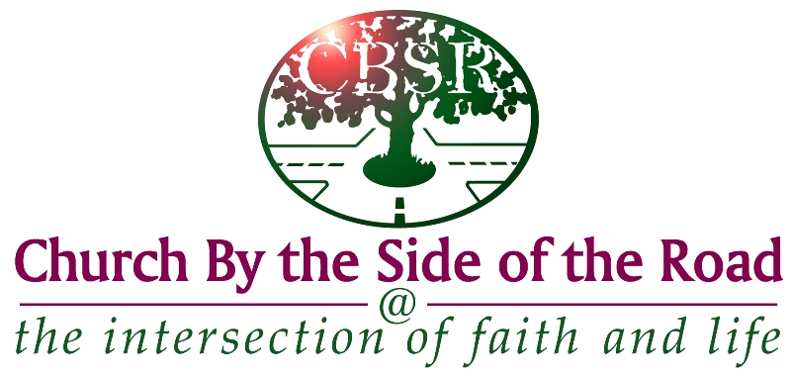
Church By the Side of the Road
2022 Scholarship Application Form
P.O. Box 68545 Tukwila, WA 98168
206-243-5024 www.cbsr.org
office@cbsr.org

Scholarship Opportunities
The Church by the Side of the Road has been generously endowed by church members who have, through gifts and memorials, established a variety of scholarship funds that provide financial resources to be awarded to students (undergrad, grad, CC, and trade school) each year. The value of each scholarship will vary according to the returns on the invested funds and the number of qualified applicants.

Application Procedure
- Applications will become available at the beginning of February during the year of application. Applications may be picked up at the church office or may be acquired from the church website.
- Completed applications, current school transcript(s), a letter of recommendation and a photo must be returned (via email or U.S. mail) to the Scholarship Committee at the Church by the Side of the Road office by Tuesday, May 31, 2022. Please check with the church office to verify that your application has been received by the church. It’s preferred that applications be typed. Additional paper may be used if more room is needed for any responses. It’s most important that your responses are detailed and complete to help the Scholarship Committee better know you. Any questions should be directed to the Scholarship Committee acting chairperson who is currently Mrs. Arizona Proctor.
- After reviewing all applications, the Scholarship Committee will contact all applicants by mail or email. The scholarship recipients will be invited to the presentation of awards during a worship service in July. Recipients are expected to attend this presentation. If unable to attend, the student must contact the chairperson of the Scholarship Committee prior to the awards service (a family member may represent the winner).
- This application is for one academic school year; however a student may reapply in following years if qualifications are met. Students may only receive a total of four scholarships per degree or certificate.

Personal/Contact Information
Name __________________________ _________ _______________________________
First Name Middle Initial Last Name
Home Address: _______________________ College Address: __________________________
_______________________ __________________________
Home Phone: _______________________ Cell Phone: __________________________
E-Mail Address: ___________________________________________________________________
Name of Parent(s)/Guardian(s): _______________________________________________________
Home Church: ________________________________ Pastor: _________________________
Home Church Address: _________________________ Home Church Phone ______________ _________________________
School Activities
List group or individual school activities in which you are an active member and identify any leadership role or responsibilities you have (attach letter).

Church Involvement
Identify areas in which you’ve been active in your church (attach letter).

Community Service
List your outside community service. Identify any leadership role or responsibilities you may have.
Please be specific (attach letter).

Qualifications

- Church membership (or regular attendee), and academic achievement requirements.
- Scholarships are for students accepted/enrolled in undergraduate, graduate, community college, or trade school.
- It’s possible that the applicant may be qualified for more than one scholarship, however only one scholarship will be awarded to an individual. Please indicate on the chart below which scholarship(s) you wish to be considered for.

Check if you are applying | Name of Scholarship | CBSR member/  Regular Attendee | Required GPA Minimum | Scholarship - Specific Essay:  (Limit response to: 1 page double spaced)
 | Dennis W. Sawyer Scholarship (Leadership) | X | 2.5 | There are several qualities one must have to become a great leader. Some of those include the ability to inspire, the ability to delegate, commitment, and confidence. Which of these qualities do you think is the most important one for a leader? Write an essay explaining why you chose that one quality.
 | Elder J. K. Samuel Scholarship (Faithful Steward) | X | 2.5 | Stewardship is a way of life that calls believers in Christ to:  - receive God’s gifts with gratitude;  - cultivate these gifts responsibly;  - share them sacrificially;  - and return these gifts with increase to God.  Share how you have used the temporal things of this world to influence people in eternal ways.
 | Hannah Gorenson Scholarship  (Visionary) | X | 2.5 | The Holy Spirit enables us to discern God’s will for our lives. God’s Holy Spirit gives each of us vision. God shows us who He is and who we are. We don’t see everything, but we see enough to live lives of purpose and power. Explain how you are living out the vision God has put in you. Give specific examples.
 | Mavis Fletcher Scholarship (Faithful Servant) | X | 2.5 | Share one story of how you have served others through your spiritual gift. (There are talents that are not spiritual gifts, such as musical or artistic abilities. We are looking for a gift used for God’s glory given at the time of your salvation. There are lists of such gifts in the contexts of the verses in the previous question: 1 Cor. 12:8-11, 28-30, Rom. 12:6-8, Eph. 4:11-12.

Academic
Section for HS Seniors only: Name of High School _______________ Date of Graduation _____________
High School Class Rank _______ out of ________ High School Grade Point Average ________

Name of College__________________________________ in City, State ____________________
College Status as of Current School Year Circle one: Freshman Sophomore Junior Senior
Cumulative College Grade Point Average____________* Major ___________ Minor_____________
Do you plan to attend college for the full school year of 2022-2023? Yes No
If yes, which school? _____________________________ in City, State _______________________
Have you received a CBSR Scholarship in the past? Yes No
If yes, which one? _______________________________ Date it was awarded ________________
Please list any recognition, awards, or honors that you have received in school, church, work, or the community in the last several years (attach letter).

Your Faith Journey
Please respond thoughtfully and specifically to each prompt or question, developing and expressing your ideas on another sheet of paper.

Typed responses are preferred. (Limit response to: 1 page double spaced).

- Outline your personal and educational goals.
- How has the Church by the Side of the Road influenced your life journey of faith?
- Describe your relationship with God; using specific examples describe your spiritual growth during the last year.
- Explain why this scholarship is important to you

References/Letter of Recommendation
Please give the name, address, and phone number of two character references who can attest to your character, personal and educational goals.
One should be an active member of the Church by the Side of the Road, and the other may be a community person. Choose one to ask to submit (via email or U.S. mail) a written Letter of Recommendation on your behalf directly to the CBSR Scholarship Committee by the June 30th deadline.
1. ________________________________ 2._____________________________________
Address ___________________________ Address _______________________________
__________________________________ ______________________________________
Phone _____________________________ Phone ________________________________
How do you know this person? 1._______________________ 2.____________________________
Which reference will be submitting a Letter of Recommendation on your behalf (must be a CBSR member/regular attendee)? ____________________

*Please include a copy of your academic transcripts with this application from high school or college as appropriate. By this application, I authorize the Scholarship Committee to verify my G.P.A., credits and class load.

Please double check that you are turning in a COMPLETE application packet. Only complete packets will be considered.

Scholarship Application Checklist:

__ Completed Application
__ Essay(s)
__ Faith Journey
__ Scholarship Specific Essay(s)
__ School Transcript
__ Recommendation Letter
...__ Photo

Your Signature _______________________________________________ Date ________________

Thank you for applying for a Church by the Side of the Road Scholarship!

